





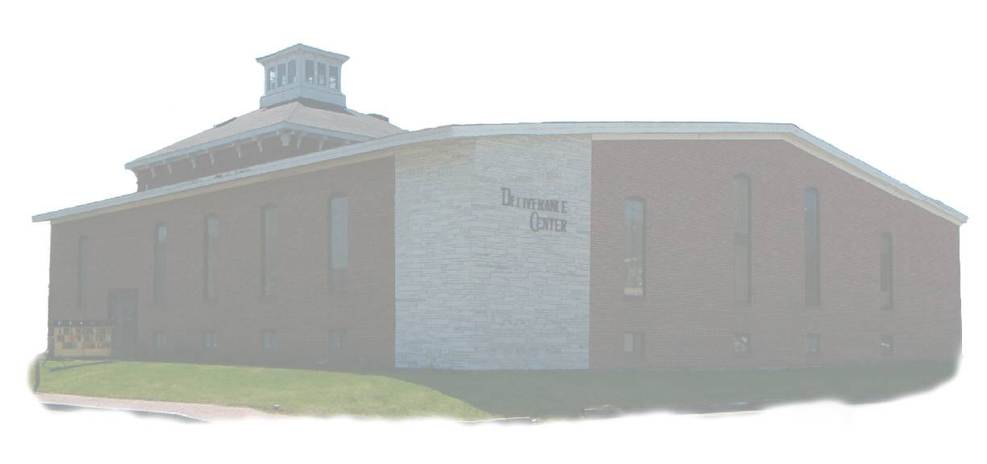

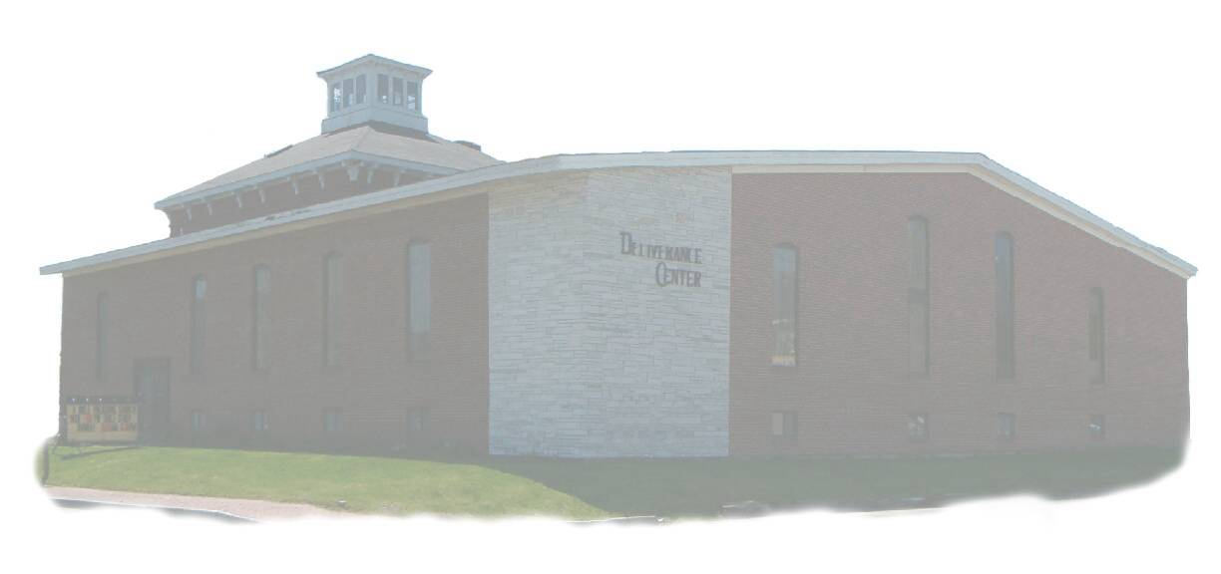

***Property of the Deliverance Center***

***1008 Congress St. Portland, Maine 04102***

***This Handbook has been entrusted to:***

***_________________________________________________***

*With my signature I affirm I have read this handbook,*

*agree to abide by the rules it contains, and promise not to mistreat or misuse this handbook in anyway.*

Resident

**Handbook**

*For All Residents*

*Of The*

*Deliverance Center*

***Introduction***

*Rev. James R. Reynolds, Sr., founded the Deliverance Center in* 1967, *with the aid of several volunteers. In time, Rev. Reynolds' own family members have become a part of daily functions at the Deliverance Center along with several very dedicated volunteers. Initially, the Deliverance Center helped and worked for the transformation of alcoholics and drug addicts. This focus is especially seen in its name, as being a place of deliverance from alcoholism or drug addiction. The Deliverance Center was also established as a local church at that time. Then, in* 1969, *it expanded to include an educational facility. The first of its schools, Deliverance Bible Institute, was established to train young adults for Christian service in a three-year course. Christian Academy of Portland was added in* 1979, *which extended the student body and curriculum to include grades K-12.*

*This handbook has been prepared to assist each member of our large family at the Deliverance Center. As each "family member" carefully observes the information in this handbook, each will find residency at the Deliverance Center most productive and rewarding. Please understand that in a large family, '*others' *is the key word. To be able to maintain our family environment, consideration for others is important. It will keep harmony in the home. The rules and guidelines in this handbook were made in an effort to be fair with everyone. Each resident must recognize that it is a* **privilege** *to be part of this family and must show a* **willingness** *to be part of this family. One's willingness is especially indicated when it is expressed by a cheerful* **attitude** *towards authority, obeying the rules, and performing one's duties.*

CRNRN200

TABLE OF CONTENTS

#### ABSENCE FROM GROUNDS 4

***ALCOHOL* & *DRUGS, ETC 5***

###### AUTHORIZATION 5

##### BATHROOMS 5

#### CHAPEL SERVICES 6

***CHORES 6, 21***

###### CHURCH SERVICES 7

***DINING ROOM* & *KITCHEN 8***

***DORMITORY 9***

***DRESS 10***

***FEES 12***

***FIRE DRILLS 12***

***LAUNDRY 12***

###### MISCELLANEOUS 13

###### MUSIC 14

***PRAYER 15***

***SCHEDULES 20***

###### TELEPHONES 15

***VEHICLES 16***

***CRNRN202VIOLATION OF RULES 17***

***ADDENDUM***

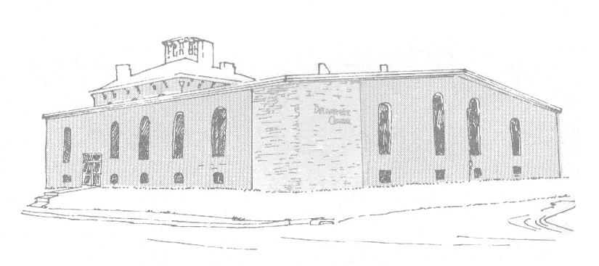





***ABSENCE FROM GROUNDS***

*1. Permission must be obtained from those in authority to leave grounds for any and all reasons. If permission is granted, resident must sign out.*

*2. It is the resident's responsibility to see that his or her duties are taken care of and that the Duty Supervisor has been informed.*

*3. Residents will be expected to plan their days in advance so they can get necessary authorization while one of the authorizing staff is available.(Exceptions for urgencies are understood but once or twice in a month is enough. No exceptions will be made Sundays.)*

*4. Residents may be absent from the grounds only at times permitted by the rules and schedule.*

*5. Each resident must be specially authorized before they may work. If authorized, residents may work Monday through Saturday; but will not be allowed to work on Sunday.*

*6. To be gone over night or to miss any services, special permission must be obtained from the Pastor and confirmed by the resident authority.*

***ALCOHOL & DRUGS, ETC.***

CS005238

*1. No alcoholic beverages of any kind shall be bought, stored, or used, on or off the premises.*

*2. No narcotics will be possessed, bought, sold, or used in any form,* ***on*** *or* ***off*** *the premises.*

*3. No tobacco products will be possessed, bought, sold, or used in any form, on or off the premises.*

*4. No medicine is to be given to any resident by another resident. No resident is allowed to keep medicine in his or her room, it must be checked in and out with*

*designated staff.*

### AUTHORIZATION

*1. Only authorized staff creates and gives directions. No resident will make controlling decisions for anyone except with regard to his or her own person and*

*possessions. In the event a resident is asked to direct the behavior of another resident, situation, etc. (e.g., baby-sitting, watch duty, phone duty, dog-sitting, etc.),*

*he or she must have special authorization.*

*2. Authorization for telephone use, leaving the grounds or for special permission, etc., will be obtained when authorizing staff is available. NOTE: Please be considerate of the time and privacy of staff and faculty members.(3 Minute limitation)*

HH10011***BATHROOMS***

*1. Be as brief as possible. Remember OTHERS (10 Minutes)*

*2. No showers or baths before 6:00 AM Monday through Saturday. ABSOLUTELY NO SHOWERS OR BATHS SUNDAY MORNING.*

*3. Bathtubs, showers, floors, walls, ceiling and drains will be left clean (from hair, toiletries, face cloths, and towels, water etc.).*

*4. Clothes will not be left in the bathroom or soaking in a sink or bathtub.*

***CHAPEL SERVICES/DEVOTIONS***

*1. All Residents, except those who receive special permission to do otherwise, are required to attend all chapel services and devotions.*

*2. Permission to be absent from chapel or devotions for any reason must be obtained from the Pastor before the absence occurs.*

*3. There will be no passing of notes or Texts during chapel or devotions. Residents are expected to reverence the chapel services and devotions as they would any other church service and keep cell phones off.(not even on vibrate)*

*4. Residents will sit in the right section facing the pulpit for chapel and devotions. When C.A.P and/or D.B.I students are present, residents will sit within three rows directly behind the last row of students, but not in the last row. When C.A.P and/or D.B.I students are not present, residents will sit where directed to do so at the time.*

Bible1A

***CHORES***

1. *Whether assigned verbally or in writing, each resident is responsible to have his or her chore done at the stated or posted time. Verbal times will supercede posted times unless otherwise directed.*
2. *Each resident will be assigned a chore and is responsible to have his chore done at the posted time. Sunday chores are generally done Sunday afternoon between services and are for the purpose of tidying or sprucing up each area.*
3. HH09146*No resident may substitute for another except with permission. The substituting resident must notify the Duty Supervisor when there is a duty change or substitution.*
4. *Duties must be attended to and the Supervisor advised before resident leaves the grounds.*
5. *If a resident is sick, he will be responsible to have the Duty Supervisor notified of his absolute inability to perform his duties.*
6. *Residents will return all cleaning tools to the utility closest after each use.*
7. *No dirty cleaning water will be dumped into the kitchen sink. Use a flush; or, if it is biodegradable, dump it out back away from travel areas.*

***CHURCH SERVICES***

*1. Residents must attend Wednesday night service, Sunday School, Sunday church services, Chapel service, morning and evening devotions, and any special services sponsored by the Deliverance Center. Residents may be required to attend special services supported by the Deliverance Center.*

*2. Passing notes is not allowed in services, except those directed to the platform.*

*3. Permission must be granted from the Pastor to stay out of church or chapel for any reason.*

*4. Residents must sit within the front four rows of the two middle sections.*

CHRCH021

***DINING ROOM* & *KITCHEN***

1. *Meals:*

*Breakfast—Will be over by 8:45 AM (No exceptions on Sunday)*

*Lunch—Will be served about 12:30 PM (Except Sunday; served after AM service)*

*Dinner—Will be served 5:00 PM (None served Sunday)*

2. *No resident is to loiter (eating, sitting, standing, walking, etc.) in the kitchen at any time. Residents will only be in the kitchen to perform duties, or by staff request.*

3. *No kitchen or dining utensils are to be taken to rooms or outside.*

4. *All meals and snacks must be eaten in the dining room.*

5. *No one is to walk around eating or drinking.*

51X233996. *No one is to chew gum in classes or church. Dispose of gum properly and do not leave it stuck anywhere.*

7. *Please do not bother the staff members while they are eating. If they are at your table, they will converse with you in a congenial manner (Mark 6:31b).*

8. *Residents may have toast, water and/or coffee* between *meals if they can do it without interfering with the kitchen staff. If milk is needed for coffee, plan your drinking habits according to the availability of someone who is specially authorized to get into the refrigerator.*

9. *Refrigerator(s) and freezer(s) are off limits to all residents at all times unless special authorization has been given to put goods in one of them or to get something out of them. (Care must be taken to close each door immediately after getting the intended item). At no time will any refrigerator or freezer be opened to "just see" what is in it.*

*10. When CA.P. students and staff are using the kitchen and dining area, residents are expected to stay outside of these areas until C.A.P. has left.*

### DORMITORY

*1. Male residents are not allowed in the girls' dorm and female residents are not allowed in the men's dorm, except by request of staff.*

*2. Residents will not put holes in the walls or mark them in any way.*

*3. All furniture in the room has been arranged for the best advantage to all concerned. No rearrangement of this furniture is to be made without special permission from the Dorm Supervisor.*

*4. Each resident is responsible for keeping his/her own room neat and clean at all times. Rooms will be inspected. There is a checklist of requirements to pass inspection in each room.*

*5. All rooms must be left unlocked unless the Dorm Supervisor has two keys and each occupant of the room has one.*

*6. Lights will not be left on in an unoccupied room unless there is fluorescent lighting and someone will use the room within 15 minutes.*

*7. The use of electrical appliances is prohibited unless special permission has been given. Permission will be given only for the following appliances: Clocks, razors,*

AD000162 *hair dryers, sewing machines, irons, lamps****, radios, tape players, CD players, and record players****. The last four are* ***allowed only at specific times along with permission****.*

*8. No stoves or heating devices of any type may be used in the dormitory rooms.*

9. No food or cooking of any type is permitted in the dormitory rooms except sealed candy and sealed drinks.

*10. Incense or candles may not be burned in rooms.*

*11. No heating lamps are to be used in rooms. No more than 60-watt bulbs are to be used in rooms, and no more than one light on per person in a room.*

*12. Residents who are sick will not be allowed in the room of another resident. The sick must stay in his or her room.*

*13. Residents are not allowed to go into the room of a sick person, unless it is their room or they are praying or ministering in some way, with permission.*

***DORMITORY (cont’d)***

*14. There must be no wrestling or roughhousing in the dorms.*

*15. Residents must be in bed with lights out by the time the curfew bell finishes ringing.*

*(10:00PM)*

*16. Lights must stay out. There will be no whispering, talking, studying, eating, drinking, etc. after the (10:00PM) bell.*

*17. Residents returning from outside ministry or for any other reason after the curfew bell will not visit with other residents. A dim light may be used when preparing for*

*bed. Resident should retire within 15 minutes.*

*18. No one is allowed to go into the room of another resident and borrow something without that resident's permission.*

*19. No resident should enter an unoccupied room of another resident.*

*20. Residents will not enter staff's rooms unless invited.*

Z2694*21. Residents must not run in the building.*

### DRESS

*1. No resident may borrow and wear any article of clothing that belongs to another resident without permission from the owner.*

*2. Residents will not buy or exchange clothing or any item from another resident.*

*3. Residents must wear robes when not fully attired in their dorms. No one will be in the general public of the Center without being fully attired. Pajamas,*

*Night gowns, and other sleepwear, are not considered appropriate attire for the general public.*

***DRESS (cont’d)***

*4. No jewelry is to be worn, except wedding and engagement rings. (Watches, tie tacks, cuff links are not considered jewelry if worn for practical purposes. Their appearance must be conservative and not outlandish.)*

*5. Hair should not be thick and heavy in the back, but tapered to give a neat appearance. It is not to touch the collar. The hair on the sides must not cover any part of the ears.*

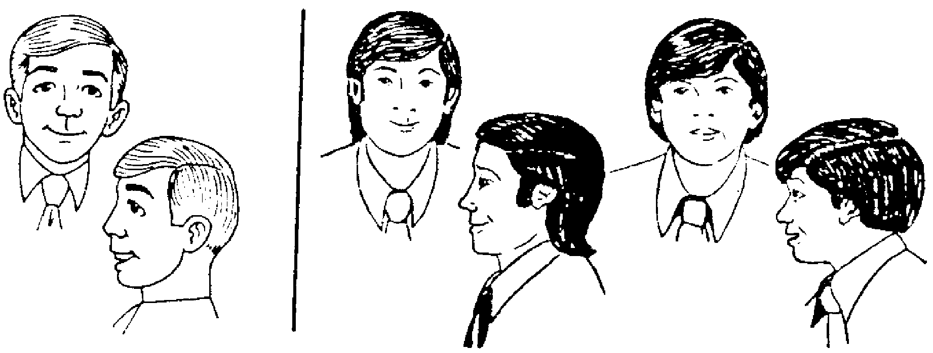

Acceptable Hair Style Unacceptable Hair Styles

1. *Mustache only for those that have always had one, then only with special permission must not come down past the corners of the mouth or over the lip.*

*Must always be neatly trimmed.*

*7. Men must be clean-shaven.*

*8. Sideburns must not come down any further than the tip of the ear lobe.*

*9. Tight or bell-bottom slacks will not be worn. Dress clothes (the best clothes a resident has) will be worn for services (no jeans).*

*10. Dress shoes and socks must be worn at all church services, not work shoes or sneakers, (unless with special permission). Shoe heels must not exceed 1½*

*inches.*

*11. Men should be fully attired in public. No tank tops, muscle shirts, shorts, stocking feet, No bare feet in sandals or bare feet are allowed outside of dorm room area.*

*12. Sweat suits or warm-up suits that are tight and/or revealing are never to be worn out of dorm room. (Proper size sweat suits are only to be worn during exercise)*

*13. Colored T-shirts may be worn if print is not offensive. White undershirts will not be worn as outerwear.*

    

***FEES***

*Each resident helps cover the costs he incurs in the following four ways:*

1. *Board ($10.00 per day)*
2. *Tithes (10% of income)*
3. *Offerings and donations given to meet the financial responsibilities of the Deliverance Center*
4. *Breakage & replacement (100%)*

**for those with no MONITARY RESOURCES*:***

A resident must work 7 hours a week at the Deliverance Center on top of chores and a clean bed room as their part in helping to cover incurred costs. (Monday through Saturday)

FIRE

FIRE DRILLS

*1. Fire regulations require that fire drills be held periodically. Detailed instructions will be given prior to drills.*

*2.* ***No one is to handle the fire extinguishers except in an emergency.***

*3. Fire escapes will be used only in case of emergency.*

***LAUNDRY***

*1. Each article of clothing must be indelibly marked.*

*2. Monday through Saturday are Laundry Days. There will be no laundry on Sunday.*

HH04251

***LAUNDRY (cont’d)***

*3. Sheets and pillowcases must be changed at least once a week.*

*4. No laundry will be left on clothesline in open sight.*

*5. Laundry will be done once a week according to posted instructions. All new residents will serve a probationary period to ensure adherence to these instructions.*

*6. If a staff assistant is doing the laundry, then each resident will bring his laundry to the laundry room by 7:00 AM and is responsible to retrieve his laundry when notified.*

*7. No resident will touch anything in the laundry room unless he is cleaning or has been given authorized instructions.*

***MISCELLANEOUS***



*1. THE TWO-FOOT RULE: 24 inches will be*



*kept between residents of the opposite sex.*

1. *Residents of either sex will not touch the*

*opposite sex. This includes praying for each*

*other. Men do not need to touch ladies and*

*ladies do not need to touch men.*

1. *Anything on the bulletin boards will not be*

marked on, torn, changed, destroyed or removed,

etc. by a resident. Nothing will be posted on the

bulletin boards without special permission.

*4. Residents will not use tools, equipment, or instruments that belong to the Deliverance Center or Revival Crusades except by special and appropriate permission.*

*5. Residents will not borrow from or loan money or other items to other residents.*

*6. During class hours, all areas in the building and areas near classrooms will be kept quiet.*

*7. Dorm areas (including halls and rooms from which noise echoes) will be kept free from excessive ("loud and obnoxious") and unnecessary noise and talking, etc.*

***MISCELLANEOUS (cont’d)***

*They will be especially quiet when someone is resting. The men's dorm area over the Learning Center will be free from sounds that might be heard in the Learning Center when anyone is studying there.*

*8. A supervisor should be advised before guests are invited to visit. Generally, visiting will not be allowed in the dorm area. Visiting should take place in common*

*and public areas.*

*9. Residents are encouraged to pray in the sanctuary before classes.*



*10. Residents are required to attend no less than one D.B.I. class per school day. Residents attending D.B.I. classes are required to be present on time (before the class begins) and shall not leave the class before it is dismissed by the teacher.*

*11. Residents will not use the church as a corridor. The balcony door in the men's dorm is a fire exit from the balcony and is not to be used as an access door to the*

*balcony by residents.*

*12. The mailbox will be checked and used by staff only. Incoming mail will be distributed to addressee. Outgoing mail may be given to appropriate staff for mailing. Residents will not tamper with or open mail that does not belong*

*to them. (Tampering with mail is a federal crime and violators may be dismissed.)*

***MUSIC***

MNOTE009*1. Instruments may be played in the dorms for ½ hour periods at the following times as long as no one is resting (or in the Learning Center, men).*

*Monday - Saturday 4:00 PM - 7:00 PM*

*2. Only CHRISTIAN/GOSPEL music is allowed. No type of Rock music including so-called "Christian Rock" is allowed.*

*3. All media (cassette tapes, CD’s, MP3’s, etc.) will be approved before anyone listens to them.*

*4. All platform instruments are private property and are not for general use.*



***PRAYER***

*1. There will be no talking when someone is praying.*

*2. The Bible should not be read during prayer time.*

*3. Residents desiring to pray after curfew must obtain permission before 10:00 PM. The resident must be in the church by the time the first curfew bell rings. He or she must stay for at least one half hour and must be in morning devotions (7:00-8:15 AM).*

***TELEPHONES***

GC300745*1. Residents will not answer phones unless requested*

*by staff, and then only for the specified time period.*

*2. Residents wanting to use the phone must first receive*

*permission from proper authority at the time they*

*make the call.*

*3. There is three-minute limit on phone calls. There*

*are exceptions to this rule ONLY by permission.*

*4. Telephones are not to be used during prayer time,*

*study halls, or after curfew. Do not ask people to call you at these times.*

1. All long distance calls will be made collect or pre-paid.

6. No information calls will be made unless prepaid.

GC300744

TN07365

TN07408

***VEHICLES***

*1. Resident vehicles must have special authorization to be in the yard and must be owned by a licensed resident, limited to one per resident, street-ready (i.e., operable, registered, insured, inspected) or arrangements made to make it so in a set time period with special authorization.*

*2. They must be parked so as not to block others at all times, particularly vehicles of staff.*

*3. Any resident driving at excessive speeds will not be allowed to carry other residents in his or her car.*

*4. Park according to the diagram below, or park elsewhere. Your vehicle should never be left in the “*NO PARKING ZONE” *and should be perpendicular to the* dashed imaginary *line (about five feet from the building).*

Fitzgerald’s Building

# *NO PARKING ZONE*

**

**

**



SW corner of Deliverance Center Building



***VIOLATION OF RULES***

*1. Residents will show respect for the Pastor and his staff.*

*2. Residents are expected to cheerfully abide by all the rules. Violation of these rules will be dealt with by the Pastor and his staff.*

*3. If a resident is asked to violate a rule, the resident is expected to inform the individual of the potential violation. Rules are guidelines for harmony and order, which are important in a “large family” environment; yet there may be exceptions to the rules. However, we expect that authorizing staff will be given the opportunity to make exceptions and no resident will assume he or she is an exception or has a blanket exception.*



***TYPICAL***

### SUNDAY SCHEDULE

*6:45 AM Wake-up*

*7:00 – 8:15 AM Prayer & Devotion*

*8:15 AM Breakfast*

*9:00 AM Breakfast Over (no exceptions)*

*10:00 AM Sunday School*

*11:00 AM Morning Service*

*2:00 PM Lunch Served (approximate time)*

*5:30 Street Meeting*

*6:00-6:30 PM Group Prayer*

*6:30 PM Evening Service*

*9:45 PM Retire to room*

*10:00 PM In bed, ready to sleep*

***TYPICAL***

***MONDAY* & *SATURDAY SCHEDULE***

*6:45 AM Wake-up*

*7:00 – 8:15 AM Prayer & Devotion*

*8:15 AM Breakfast Served*

*8:45 AM Breakfast Over*

*9:00 – 9:30 AM Bible Study/ Bible Reading—absolutely no talking*

*12:00 PM Lunch Served*

*5:00 PM Dinner Served*

*7:00 – 8:00 PM Prayer & Devotion*

*9:45 PM Retire to Room*

*10:00 PM In bed, ready to sleep, lights out*

***TYPICAL***

***TUESDAY THRU FRIDAY SCHEDULE***

***(Oct* - *May)***

*6:45 AM* *Wake-up*

*7:00 – 8:15* *AM* *Prayer & Devotion*

*8:15 AM* *Breakfast Served*

*8:30 AM* *Breakfast Over*

*8:45* *AM* *First Period*

*9:30 AM Second Period*

*10:15* *AM* *Class Break*

*10:30 AM* *Third* Period

*11:15 AM* *Fourth Period*

*12:05 PM* *Chapel Period*

*1:00 PM Lunch Served*

*5:00 PM* *Dinner Served*

*7:00* – 8:*00* *PM*  *Prayer & Devotion*

*10:45 PM* *Retire to Room*

*11:00 PM* *In bed,* ready *to sleep, lights out*

***Typical***

***Weekly Services***

*Sunday School 10:00 A.M.*

*Sunday Morning Service 11:00 A.M*

*Street Meeting 5:30 P.M.*

*Sunday Prayer 6:00 P.M.*

*Sunday Evening Service 6:30 P.M.*

*Wednesday Prayer 6:00 P.M.*

*Wednesday Bible Study 7:00 P.M.*

*Friday Youth Meeting 6:00 P.M.*



**Descriptions of Daily Chores**

*These descriptions are subject to modification, so refer to posted descriptions and updates.*

**A. Floor Chore**

*Sweep the floors in the kitchen, dining room, nursery, main hallway, and wash each floor. Scrub floors with nylon bristle brush; remove all blacks marks, stuck-on food, gum, tar, grease, and dirt. If this chore is started before 6:00 PM Saturday, then it may need to be wet mopped before curfew.*

**B. Stairs and Throw Rug Chore**

*Sweep and wash front and back stairs in main hallway going to the second floor. Take all throw rugs that are in the kitchen, dining room, main hallway, and church vestibule outside and "shake" them out. Return them to their respective places. DO NOT DO THIS CHORE WHILE OTHERS MAY BE SLEEPING IN LADIES’ DORM OR IN THE APARTMENT. Scrub stairs with nylon bristle brush; remove all blacks marks, stuck-on food, gum, tar, grease, and dirt. Clean windows in dining room, and in back door. Clean the woodwork in the main hallway (front and back): baseboard, trim, doors, and walls. It may be necessary to use a toothbrush to reach hard-to-get-to areas. Polish both banisters with furniture polish.*

**C. Kitchen Chore**

*Scrub clean all kitchen counters, refrigerators, stove and oven (especially the sides of the stove), and the inside and outside of the microwave. Move items on the floor and clean under and behind them. It may be necessary to use a toothbrush to reach hard-to-get-to areas. Clean the windows, walls and woodwork: baseboard, trim, and doors.*

**D. Dishes Chore**

*Prep dishes and fill the dishwasher throughout the day. Put away all clean dishes. Wash all pans and items that are not washed in the dishwasher. Clean all items that cannot be washed in the dishwasher and all small appliances, such as: toaster, mixer, coffee maker, etc. Visually inspect for cleanliness all dishes, containers, pots, pans, and utensils in the cupboards and drawers and organize each area. Wash table/tablecloth and arrange items on the table neatly, or remove them.*

**E. Trash Chore**

*Empty all trashcans and put in new trash liners. (Kitchen, dining room, nursery, hallways, and restrooms in basement) Lawns and back yard need to be cleared of paper trash and waste*

*from consumable products such as plastic drink containers, etc. Clean all dirty trashcans.*

*Thoroughly inspect lawns, backyard, and driveways; and. remove all trash. Be sure to ask proper authority before discarding anything that may be someone's property.*

**F. Vacuum Church Chore**

*Pick up all loose items in the sanctuary-books, pens, pencils, clothes, and coats, etc.-and put songbooks and* *Bibles on table in vestibule and place them neatly on the coat rack. Vacuum sanctuary and platform. DO NOT move anything on the platform or remove anything from the platform. Inspect chairs for cleanliness. Make sure they are free from bits of trash, lint, hair, gum ,food, and burdocks. Be sure to vacuum between each row as well as the common aisles. Arrange seats according to the established pattern.*

**G. Laundry & Boiler Room Chore**

*Sweep floors and stairs. Pick up all loose clothes and trash. Wipe down machines. Dust boiler, pipes, and plumbing fixtures. Wash windows. Knock down cobwebs. Clean the food storage room: dust shelves and all items on them; wash window; sweep and wash floors.*

**H. Men's Dorm Restroom Chore**

*Wipe down sinks, counters, mirrors, shower stall, and toilet tank. Using a toilet brush, clean the entire toilet bowl, inside and out. Sweep, wash, and disinfect the floor. Empty the trash. Clean window, walls, and woodwork. Clean and disinfect shower and wall around toilet bowl.*

**I. Church Restroom & Vestibule Chore**

*Wipe down sinks, counters, mirrors, and toilet tanks. Using a toilet brush, clean both toilet bowls, inside and out. Sweep, wash, and disinfect the floors. Vacuum upper landing, throw rugs, and steps. Empty the trash. Clean window, walls, and woodwork. Clean and disinfect wall around toilet bowls. Be sure all paper products are sufficiently replenished for Sunday usage.*

**J. Men's Dorm Chore**

*Vacuum all hallways and stairs in men's dorm and the landing at the foot of the stairs by the kitchen. Report any articles or items that are in these areas. Dust and tidy tape and book table. Polish handrail, and the door and trim to balcony. Clean hall window, walls, and woodwork.*

**K. Church Basement Chore (Open Area, Classrooms)**

*Sweep open area and hallway, and vacuum classrooms. Wash floor in open area every 2 to 3 weeks. Wash travel area to classrooms and hallway floor weekly. Clean windows (glass), clean windowsills and wall "step outs. "Arrange all furniture in an acceptable manner (SEE Duty Supervisor). Dust and polish woodwork, podiums, and desks, as needed. Wash walls every 6 to 8 weeks. Empty trash containers when full. DO NOT CLEAN MARKER BOARDS WITHOUT DUTY SUPERVISOR’S AUTHOR-IZATON AND INSTRUCTION.*

**L. Yard Chore**

*Thoroughly inspect lawns, backyard, and driveways; and, remove all trash. Be sure to ask proper authority before discarding anything that may be someone's property. Growth season: Mow and trim the lawn. Snow season: Keep walkways clear, sanded, and/or salted.*



It is necessary that everyone makes sure his or her dishes are **fully scraped, rinsed, and placed in the bus pan**. (Hosts and hostesses need to do this for their guests. Children under twelve must have the supervision of a parent or responsible guardian.)

As a resident, it is important for you to follow the above posting, and the following related instructions:

1. Scrape loose food particles into the “slop bucket” (NOT in the regular trash.)

2. Put enough water in or on the dish or utensil to rinse it and then turn the faucet off.

1. Use the scrub brush to remove all food residues.
2. Place the scraped, rinsed, and scrubbed dishes and utensils in the designated “bus pan.”
3. **Only designated persons will load the dishwasher.**

A. Open the dishwasher door, but stand nearby dishwasher**.**

B. Place the item in the appropriate tray:

1. Top tray: glasses, cups, saucers, desert plates, small bowls, large cooking utensils that will not fit on the door.
2. Bottom tray: plates, pitchers, bowls, any other large items that are not too big for the dishwasher
3. Door tray: silverware, sharp knives, cooking utensils, etc.

C. If the dishwasher is full *of* unwashed dishes, then place one heaping teaspoon *of* detergent (stored under the kitchen sink) in each soap cup (bottom right *of* door); close the door, and carefully turn the knob clockwise until the cycle begins. Do not change any *of* the other settings.

6. If the dishwasher is full *of* washed dishes, then dry them and put them in their proper places. When in doubt—ASK.